|  |
| --- |
| School of Engineering and Industrial Trades  Electrical Engineering Technology |

Basic Instrumentation LAB

AEPC 1203

Lab 6 Introduction to Instrumentation Measurement

|  |  |
| --- | --- |
| Name: Islam Azzam | Student ID: 60105790 |
| Lab Date: 17/05/2022 | Instructor: Mr. Mohammed Atif |
| Due date: 20/05/2022 | Total Mark: __________/100 |

Lab title: Introduction to Instrumentation Measurement

|  |  |  |
| --- | --- | --- |
| Device Name | Picture | Model Number |
| Thermocouple Calibrator | Figure 1 | 714 |
| RTD Calibrator | Figure 2 | 712 |
| Process Calibrator | Figure 3 | 744 |
| Pressure Calibrator | Figure 4 | 718-30G |
| Multimeter | Figure 5 | 175 |
| Loop Calibrator | Figure 6 | 707 |
| HART Communicator | Figure 7 | 475 |

Data-Sheets will be listed at the end of the report

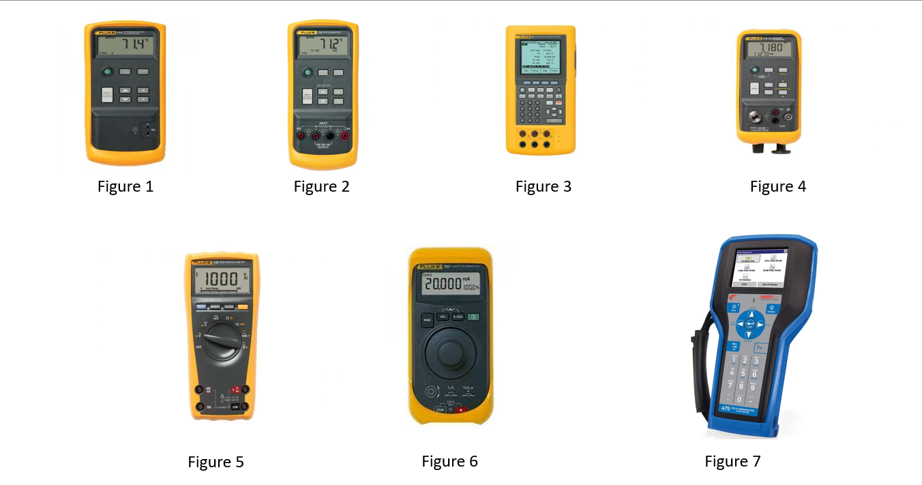

-Purposes of the Instrumentation

1. Thermocouple Calibrator: test the accuracy of temperature sensors through sophisticated electronic circuitry rather than comparison to a reference. In this way, they are not true calibrators though they are able to provide technicians a simple, cost-effective way to field test thermocouples and RTDs by comparing the temperature measured by the sensor with the voltage or milliamp signal produced.
2. RTD Calibrator: handheld tool for calibrating RTD (Resistance Temperature Detector) transmitters, including most pulsed transmitters. It simulates and measures seven different types of RTDs, in units of °C or °F. It also simulates and measures resistance in units of ohms. It does not source and measure simultaneously.
3. Process Calibrator: used for basic measuring, testing and regulation techniques for setting and verifying test installations and instrumentation. A PCE calibrator is made of high strength materials and is lightweight and easy to be used handheld or can be fixed installed if necessary.
4. Pressure Calibrator: is simply a pressure measuring device capable of verifying (or calibrating) the pressure reading of another pressure measuring device. These devices might also be called pressure standards. The pressure calibrator must be more accurate than the device being calibrated.
5. Multimeter: is a test tool used to measure two or more electrical values—principally voltage (volts), current (amps) and resistance (ohms). It is a standard diagnostic tool for technicians in the electrical/electronic industries.
6. Loop Calibrator: designed to troubleshoot 4-20 mA current loops. These versatile instruments are capable of measuring current, sourcing current to unpowered devices in a loop, as well as simulating the operation of loop-powered 4-20 mA transmitters.
7. HART Communicator: HART and FOUNDATION fieldbus devices are supported, allowing you to configure, maintain, and troubleshoot them. Follow all applicable standards and procedures when utilizing the 475 Field Communicator to communicate with devices.

POWER TOOLS:

1. Main Power Controller: Receiving an analog signal, such as a 4 to 20 mA signal from a temperature controller, or manual settings established using a variable resistor, a Power Controller continually adjusts the power utilized by a heater with phase control or optimum cycle control.
2. TTI Power Supply: Most Aim-TTi power supplies have segregated main outputs that automatically switch between constant voltage (CV) and constant current (CI) modes. This permits greater voltages or currents to be achieved by wiring in series or parallel.
3. Dual 24V DC Power Supply: Is a regular direct current power supply is a dual power supply. It may deliver both positive and negative voltage. It helps to prevent system damage by ensuring a consistent power supply to the device. A source of DC power is required by many electronic circuits.
4. Multi-Function Calibrator and Control Centre: When utilizing EasyCal other manual control programs, the CCPAD is a keypad module that allows for easy data entering, deviation, and navigation. The calibrators can also be used with the included wireless keyboard and mouse or through touch screen.
5. Precision Pressure Indicator: It is used to verify the accuracy of field pressure indicators/transmitters or as a laboratory standard and wherever there is a need for a high level of pressure accuracy in manufacturing, testing and calibration of pressure instruments or gauges.
6. Precision Calibrator: It measures and sources almost all process parameters to calibrate almost anything. Use it to test sensors and valves, and to test and calibrate transmitters.
7. AC Supply: An AC/DC power supply's principal function is to convert alternating current (AC) into a steady direct current (DC) voltage, which can subsequently be used to power various electrical devices. Alternating current is utilized to carry electric power from generators to end users via the electric grid.

Data Sheets:

* Thermocouple Calibrator 714

<https://www.digchip.com/datasheets/parts/datasheet/1728/FLUKE_714-pdf.php>

* RTD Calibrator 712

<https://www.fluke.com/en-us/product/calibration-tools/pressure-calibrators/fluke-712>

* Process Calibrator 744

<https://www.fluke.com/en-us/product/calibrationtools/multifunction-calibrators/fluke-744>

* Pressure Calibrator 718-30G

<https://www.fluke.com/en/product/calibration-tools/pressure-calibrators/fluke-718>

* Multimeter 175

<https://www.fluke.com/en/product/electrical-testing/digital-multimeters/fluke-175>

* Loop Calibrator 707

<https://www.fluke.com/en/product/calibration-tools/ma-loop-calibrators/fluke-707>

* HART Communicator 475

<https://www.instrumart.com/products/30890/emerson-475-field-communicator>